New Databases for Replication on Always ON

1. Create the New Database on Primary Server with user requirements.
2. Take the Full and T-log backup (New database) on Primary server.
3. Restore the new database (restore with norecovery) on secondary servers.
4. Add Database to a SQL Server Always On Configuration

Step 1: The first step is to check the existing AG configuration and its state. The AG should be healthy before proceeding to the next step. You can check dashboard report as well the Availability Group tree in SSMS. You can see AG looks healthy in the below screenshot.

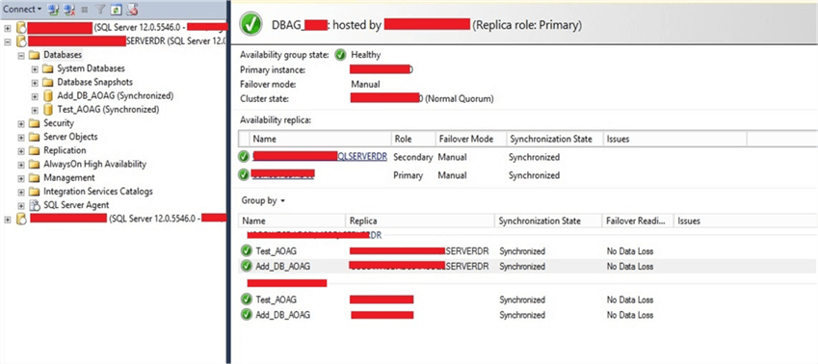

Step 2: Now identify your database that needs to be added to the AG. Once you have identified the database, you need to prepare it on the secondary replica as a secondary database by restoring it to a norecovery state with a copy of a full backup and a transaction log backup from the primary database. You can see I have restored this database on the secondary replica in the below screenshot and it shows the database is a restoring state.

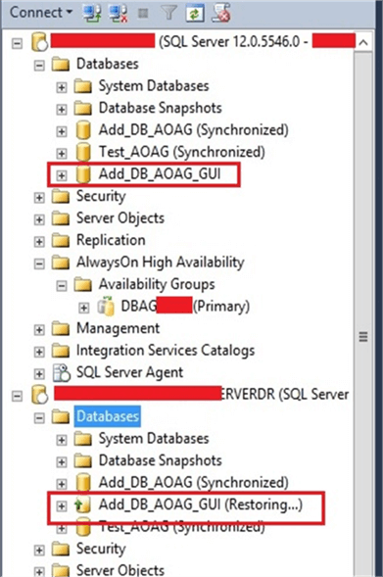

Step 3: Once you prepared the secondary database, the next step is to add this database to the AG configuration. Connect to the primary replica and expand AlwaysOn High Availability and Availability Groups in SSMS as shown below. Right click on theAvailability Group name and choose Add Database... as shown in below image.

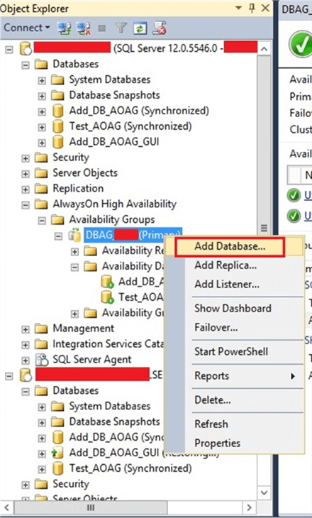

Step 4: You will get the screen once you click Add Database. Click on Next button to proceed.

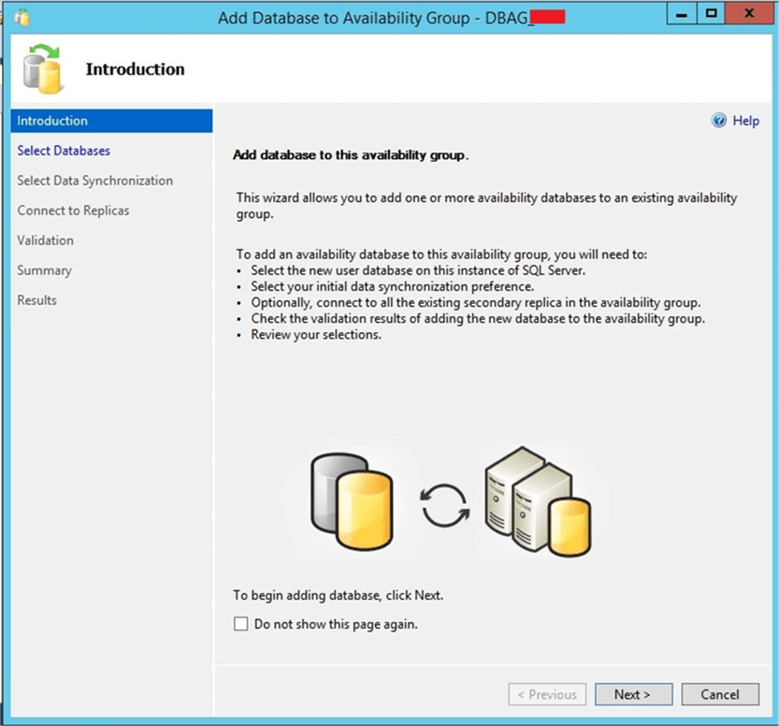

Once you click on Next button, you will get the below screen to choose the database.

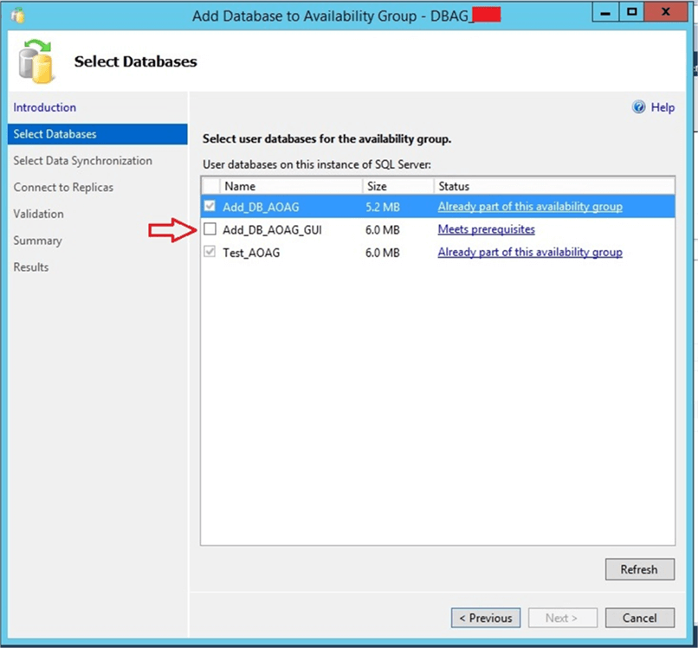

Check database “Add_DB_AOAG_GUI”, to add to the AG.

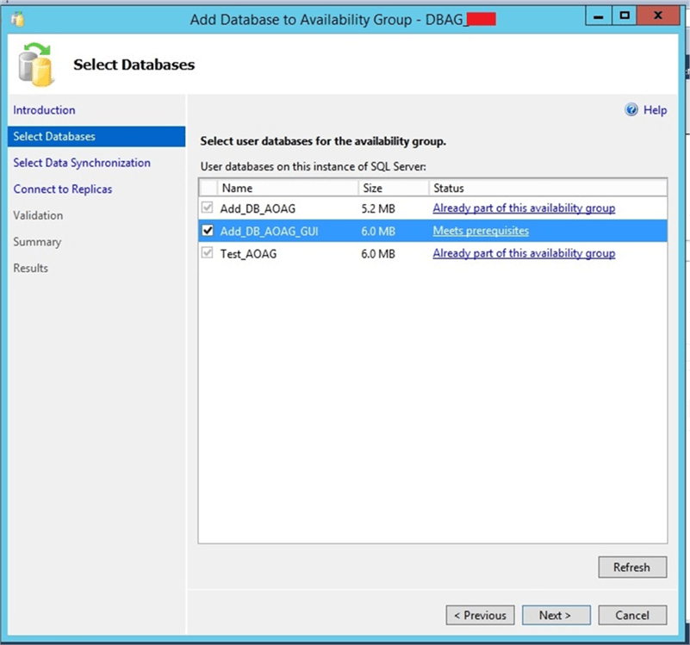

Click on Next button after selecting the database and you will get the below screen to proceed. As we have already prepared the secondary database, we will choose the “Join Only” option and click Next.

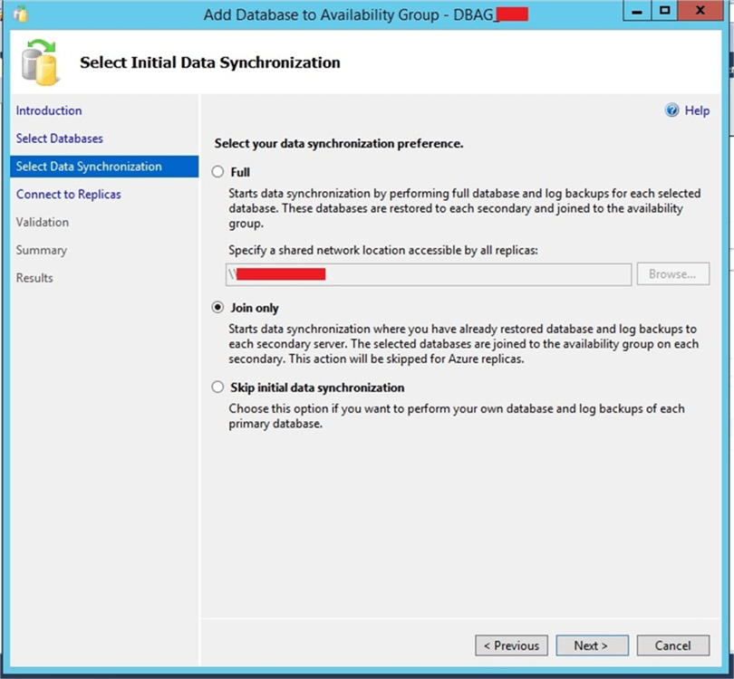

You will then get this screen.  Click Connect to proceed.

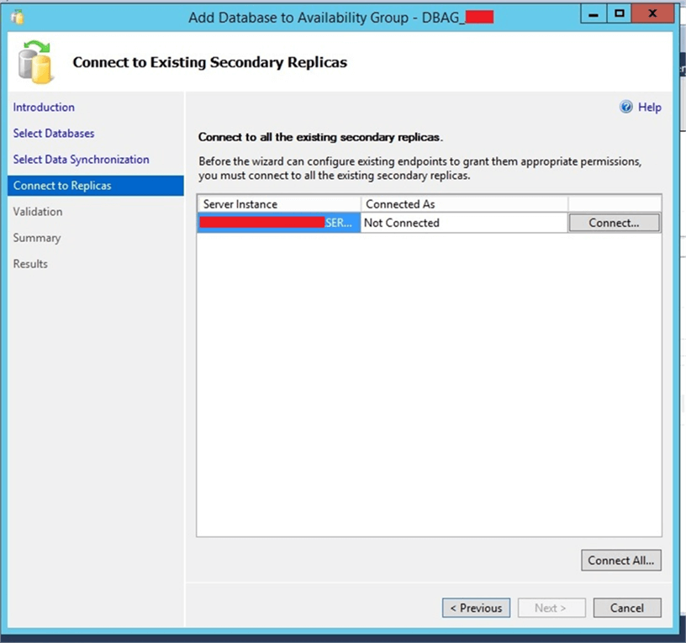

 Clicking on the Connect above will open a window to enter credentials to connect to the secondary replica.

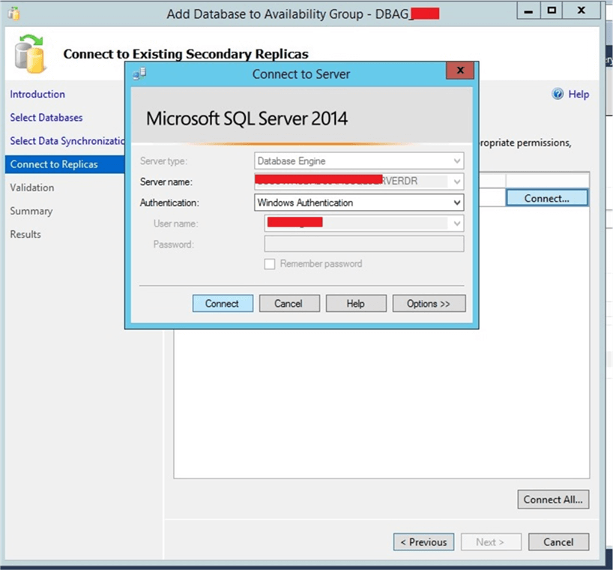

Once you connect to the secondary replica you will get the below screen. Then click on the Next button.

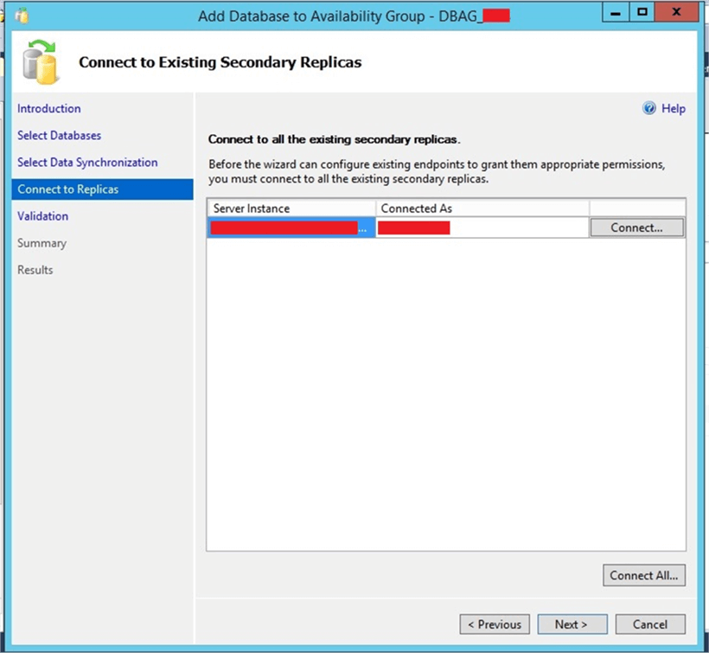

After clicking Next it will check validation rules for this configuration. If they all pass, click Next to proceed.

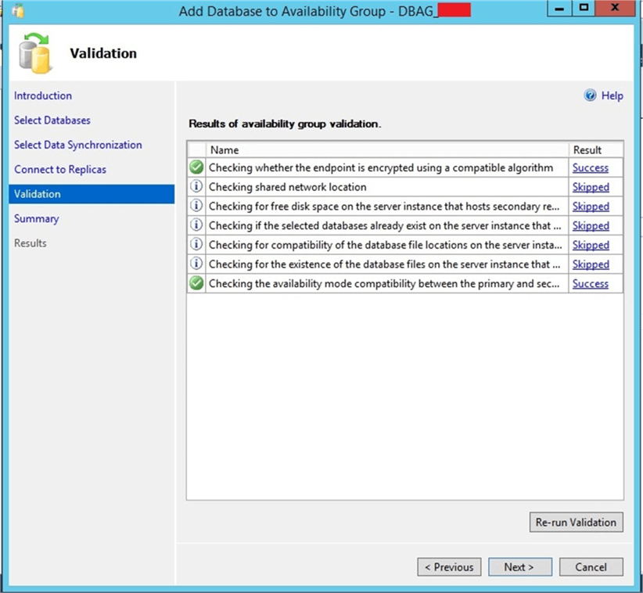

Then you will get a summary page to verify the details as shown in the below image. This is final window of this configuration. Click on the Finish button to add the database to the AG.

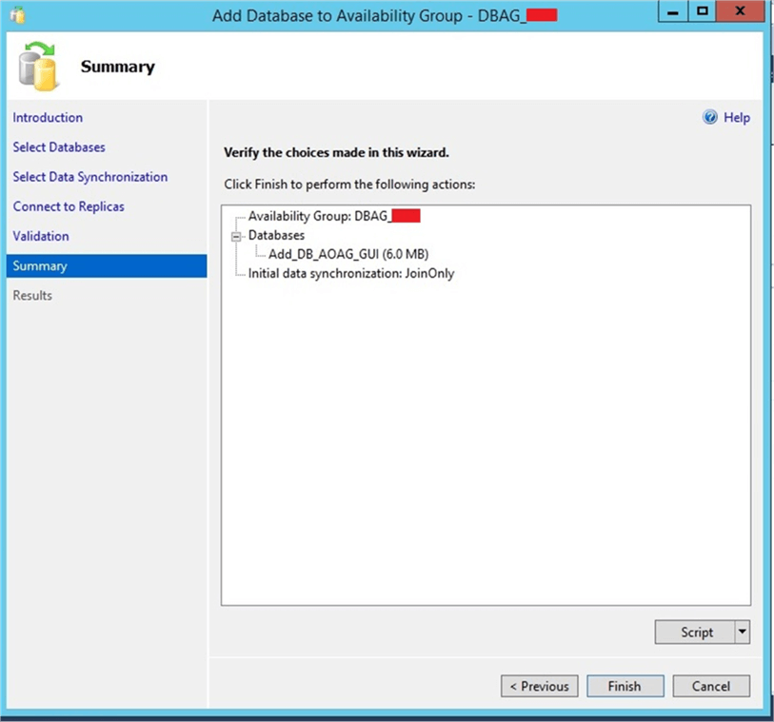

You will see the following that shows the database has been added to the AG.  Click Close to close this window.

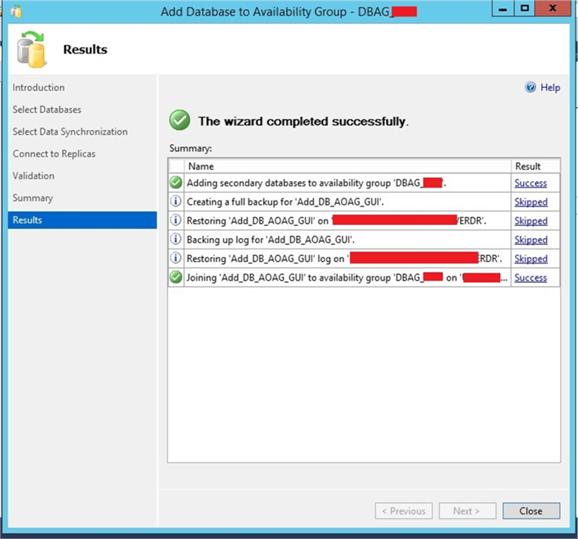

Step 5: Now the database has been added to the existing AG. Next, we will check and validate this change. We can run the dashboard report again or check in SQL Server Management Studio. I checked both ways and you can see the database has been added to this AG in the below image and our Availability Group is running healthy post adding this database.

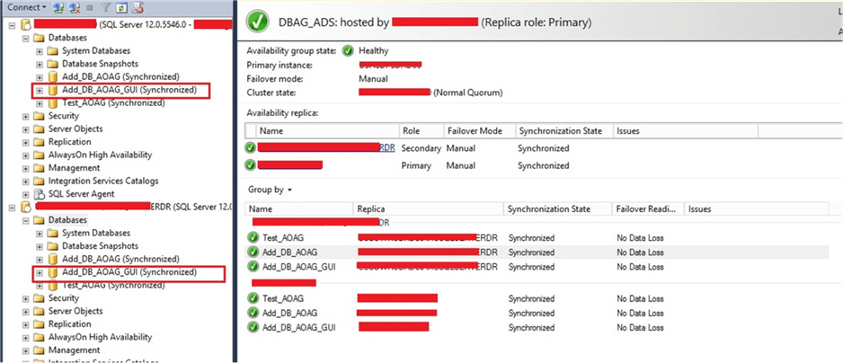

Configure the publisher for transactional replication

In this section, you create a transactional publication by using SQL Server Management Studio to publish a filtered subset of the **Product** table in the **AdventureWorks2012** sample database. You also add the SQL Server login used by the Distribution Agent to the publication access list (PAL).

Create a publication and define articles

Connect to the publisher in SQL Server Management Studio, and then expand the server node.

Right-click **SQL Server Agent** and select **Start**. The SQL Server Agent should be running before you create the publication. If this step does not start your agent, you'll need to do so manually from SQL Server Configuration Manager.

Expand the **Replication** folder, right-click the **Local Publications** folder, and select **New Publication**. This step starts the New Publication Wizard:

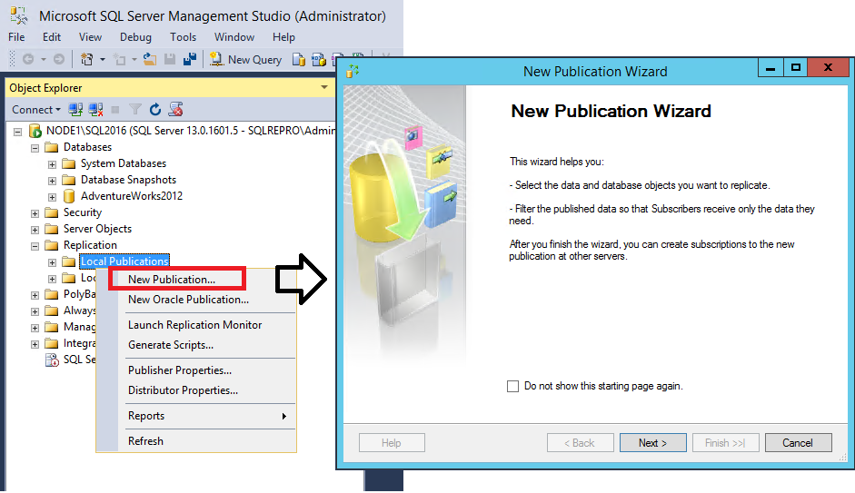

On the **Publication Database** page, select **AdventureWorks2012**, and then select **Next**.

On the **Publication Type** page, select **Transactional publication**, and then select **Next**:

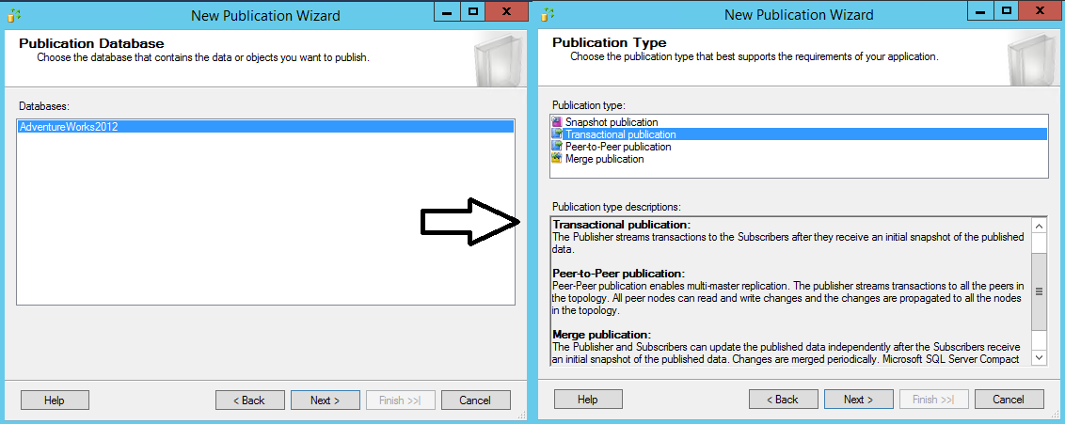

On the **Articles** page, expand the **Tables** node and select the **Product** check box. Then expand **Product** and clear the check boxes next to **ListPrice** and **StandardCost**. Select **Next**.

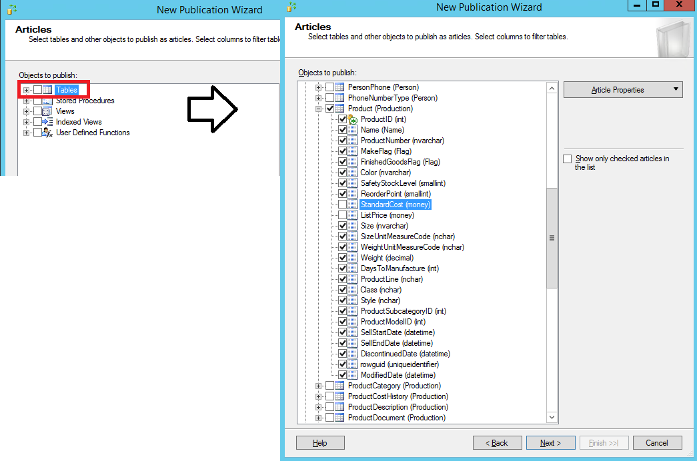

* For the agent security setup, you may check how other publications were set up – on publisher, right click a publication, properties, agent security,

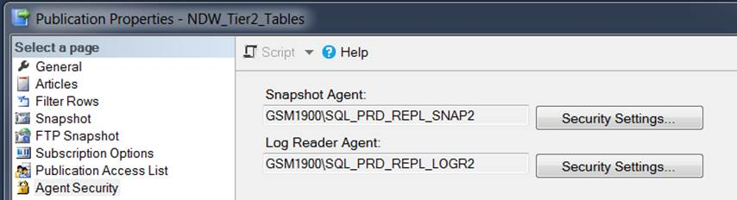

* For log reader agent, please specify either GSM1900\SQL_PRD_REPL_LOGR1 or GSM1900\SQL_PRD_REPL_LOGR2.
* For the snapshot agent, please use either GSM1900\SQL_PRD_REPL_SNAP1 or GSM1900\SQL_PRD_REPL_SNAP2.
* You may find the passwords in CyberArk

On the **Complete the Wizard** page, type **AdvWorksProductTrans** in the **Publication name** box, and select **Finish**:

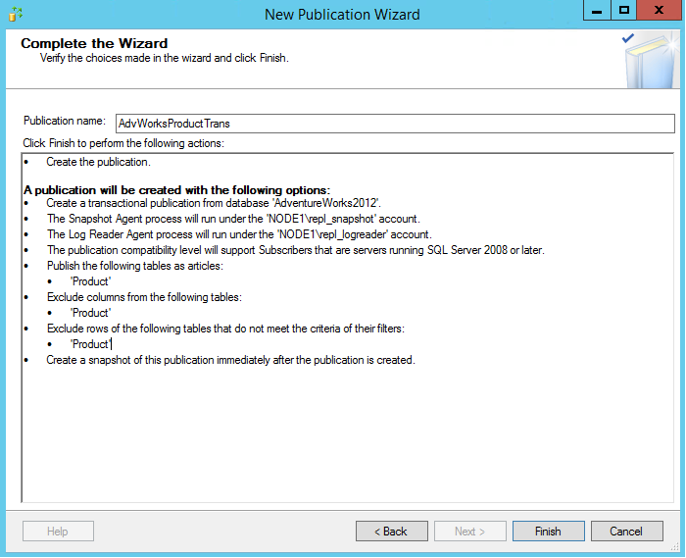

After we create a new database on an instance with AG/replication setup, we need redirect publishers to its AGL on distro server

|  |
| --- |
| USE distribution;  EXEC sp_redirect_publisher  [ @original_publisher = ] 'original_publisher',  [ @publisher_db = ] 'database_name'  [ , [ @redirected_publisher = ] 'new_publisher' ] |

Please disable anonymous and immediate sync

use publicationdb

EXEC sp_changepublication

@publication = 'PublicationName',

@property = 'allow_anonymous',

@value = 'FALSE';

EXEC sp_changepublication

@publication = 'PublicationName',

@property = 'immediate_sync',

@value = 'FALSE';